**Practical No: 5** Ninad Karlekar 22306A1012 Date: 18/04/2023

Aim: Configure and verify path control using PBR (Policy Based Routing).

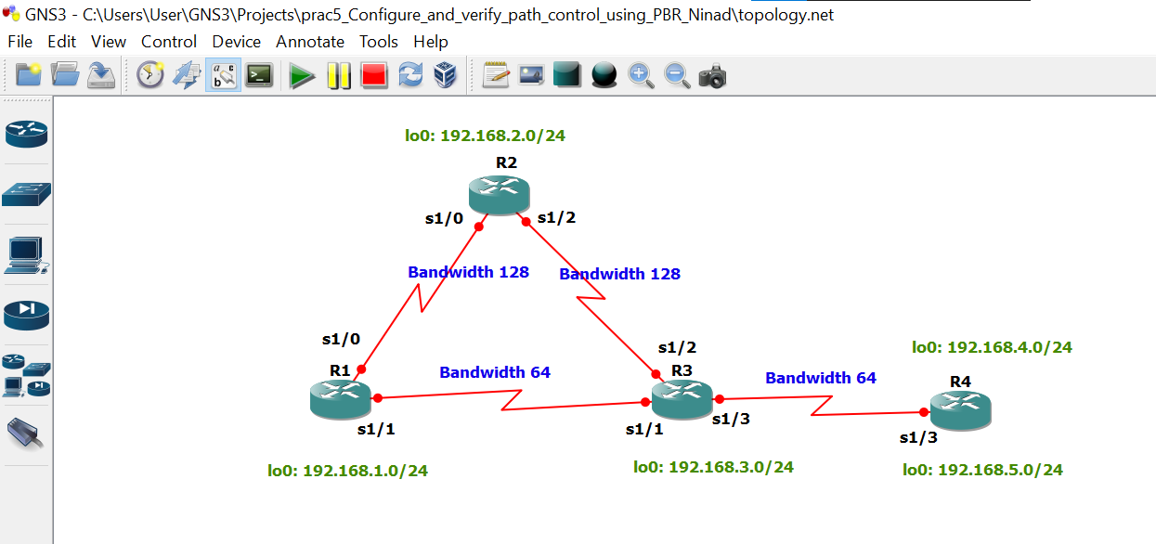

Take 4 routers -> Configure -> slots -> NM-4T

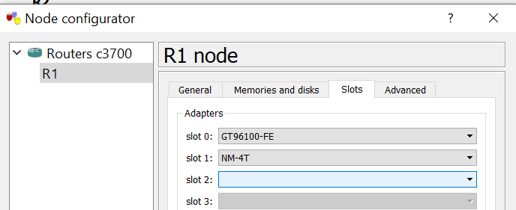

**STEP 1: Perform IP configuration**

**On router 1 console**

R1#conf t

R1(config)#hostname r1

r1(config)#int s1/0

r1(config-if)#ip add 172.16.12.1 255.255.255.0

r1(config-if)#bandwidth 128

r1(config-if)#no sh

r1(config-if)#int s1/1

r1(config-if)#ip add 172.16.13.1 255.255.255.0

r1(config-if)#bandwidth 64

r1(config-if)#no sh

r1(config-if)#int lo0

r1(config-if)#ip add 192.168.1.1 255.255.255.0

r1(config-if)#do sh ip int br | include up

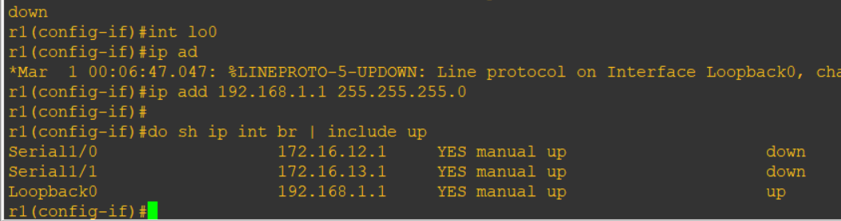

**On router 2 console**

R2#conf t

R2(config)#hostname r2

r2(config)#

r2(config)#int s1/0

r2(config-if)#ip add 172.16.12.2 255.255.255.0

r2(config-if)#bandwidth 128

r2(config-if)#no sh

r2(config-if)#

r2(config-if)#int s1/2

r2(config-if)#ip add 172.16.23.2 255.255.255.0

r2(config-if)#bandwidth 128

r2(config-if)#no sh

r2(config-if)#

r2(config-if)#int lo0

r2(config-if)#ip add 192.168.2.2 255.255.255.0

r2(config-if)#

r2(config-if)#do sh ip int br | include up

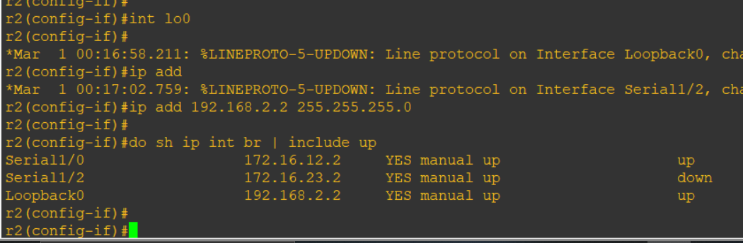

**On router 3 console**

R3#conf t

R3(config)#hostname r3

r3(config)#

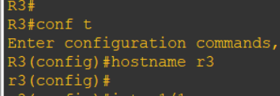

r3(config)#int s1/1

r3(config-if)#ip add 172.16.13.3 255.255.255.0

r3(config-if)#bandwidth 64

r3(config-if)#no sh

r3(config-if)#

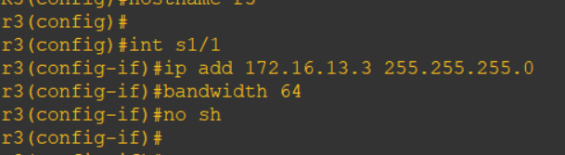

r3(config-if)#int s1/2

r3(config-if)#ip add 172.16.23.3 255.255.255.0

r3(config-if)#bandwidth 128

r3(config-if)#no sh

r3(config-if)#

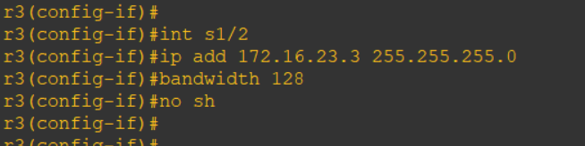

r3(config-if)#int s1/3

r3(config-if)#ip add 172.16.34.3 255.255.255.0

r3(config-if)#bandwidth 64

r3(config-if)#no sh

r3(config-if)#int lo0

r3(config-if)#ip add 192.168.3.3 255.255.255.0

r3(config-if)#

r3(config-if)#do sh ip int br | include up

**On router 4 console**

R4#conf t

Enter configuration commands, one per line. End with CNTL/Z.

R4(config)#hostname r4

r4(config)#

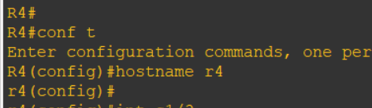

r4(config)#int s1/3

r4(config-if)#ip add 172.16.34.4 255.255.255.0

r4(config-if)#bandwidth 64

r4(config-if)#no sh

r4(config-if)#

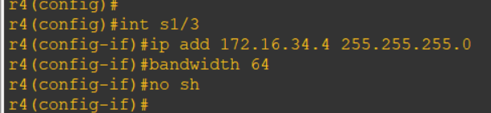

r4(config-if)#int lo0

r4(config-if)#ip add 192.168.4.1 255.255.255.0

r4(config-if)#

r4(config-if)#int lo1

r4(config-if)#ip add 192.168.4.1 255.255.255.0

r4(config-if)#ip add 192.168.5.1 255.255.255.0

r4(config-if)#

r4(config-if)#do sh ip int br | include up

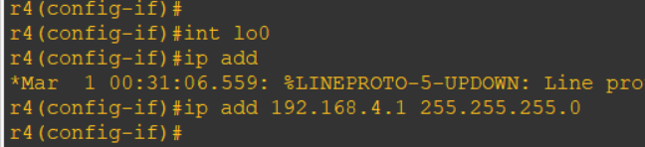

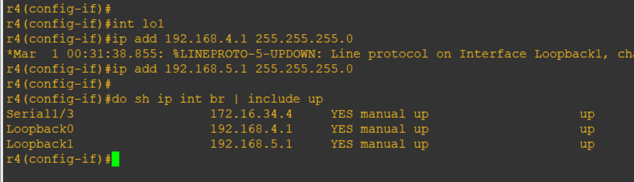

**STEP 2 : Configure eigrp on all routers**

**On router 1 console**

r1(config)#router eigrp 1

r1(config-router)#network 172.16.12.0 0.0.0.255

r1(config-router)#network 172.16.13.0 0.0.0.255

r1(config-router)#network 192.168.1.0

r1(config-router)#no auto-summary

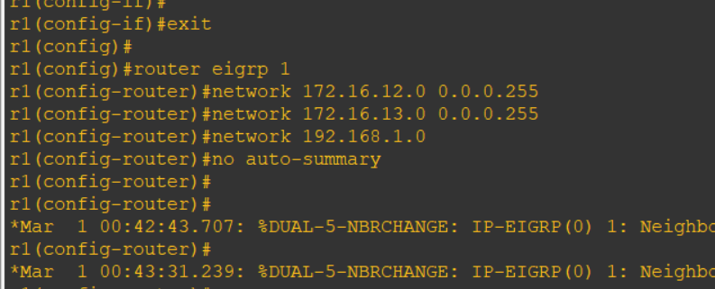

**On router 2 console**

r2(config)#router eigrp 1

r2(config-router)#network 172.16.12.0 0.0.0.255

r2(config-router)#

r2(config-router)#network 172.16.23.0 0.0.0.255

r2(config-router)#network 192.168.2.0

r2(config-router)#no auto-summary

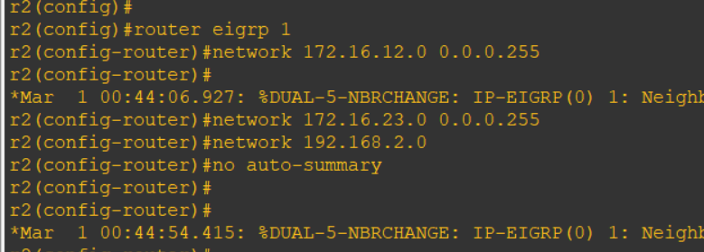

**On router 3 console**

r3(config-if)#router eigrp 1

r3(config-router)#network 172.16.13.0 0.0.0.255

r3(config-router)#network 172.16.13.0 0.0.0.255

r3(config-router)#network 172.16.23.0 0.0.0.255

r3(config-router)#network 172.16.34.0 0.0.0.255

r3(config-router)#network 192.168.3.0

r3(config-router)#no auto-summary

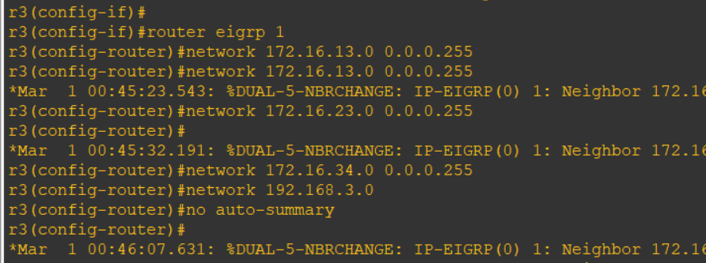

**On router 4 console**

r4(config)#router eigrp 1

r4(config-router)#network 172.16.34.0 0.0.0.255

r4(config-router)#

r4(config-router)#network 192.168.4.0

r4(config-router)#network 192.168.5.0

r4(config-router)#no auto-summary

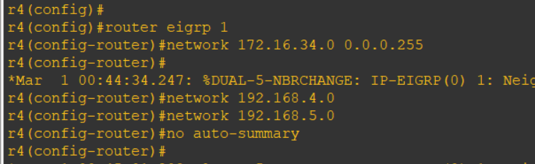

**STEP 3: Command on all routers**

do sh ip route

r4(config)#do ping 192.168.1.1

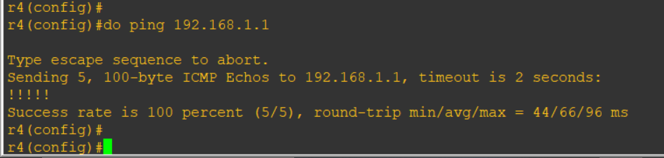

r1(config)#do ping 192.168.4.1

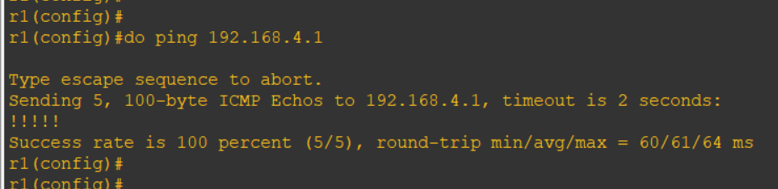

**R4**

r4(config)#do traceroute 192.168.1.1 source 192.168.4.1

r4(config)#

r4(config)#do traceroute 192.168.1.1 source 192.168.5.1

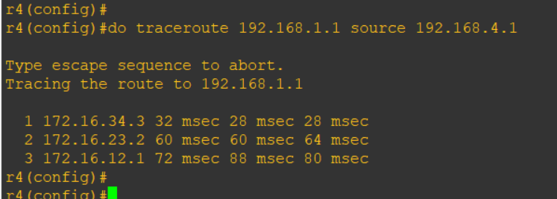

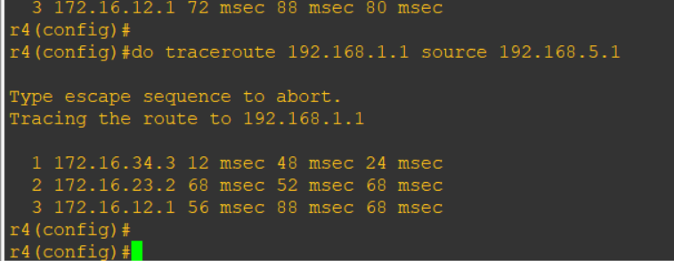

Configure PBR to provide path control

* All traffic from source 192.168.5.1 should take route R4 -> R3 -> R1
* All traffic from source 192.168.4.1 should take route R4 -> R3 -> R2 -> R1

**On router 3 console**

r3(config)#ip access-list standard pbr-acl

r3(config-std-nacl)#permit 192.168.5.0 0.0.0.255

r3(config-std-nacl)#exit

r3(config)#

r3(config)#

r3(config)#route-map r3-to-r1 permit

r3(config-route-map)#match ip address pbr-acl

r3(config-route-map)#

r3(config-route-map)#set ip next-hop 172.16.13.1

r3(config-route-map)#exit

r3(config)#

r3(config)#int s1/3

r3(config-if)#ip policy route-map r3-to-r1

r3(config-if)#end

**On router 4 console**

r4(config)#do traceroute 192.168.1.1 source 192.168.4.1

r4(config)#do traceroute 192.168.1.1 source 192.168.5.1

